Health share image

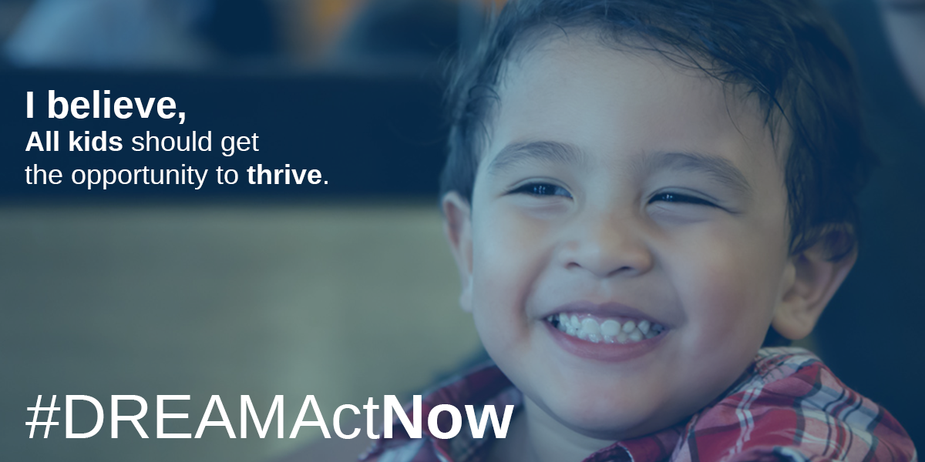

Accompanying Twitter tweets

Congress must pass the #DreamActNow to protect the health & well-being of immigrant families. Delay means unmet healthcare needs & harm of stress and fear for 800,000 Dreamers & their families. @SenSherrodBrown, demand a vote now. #ProtectOurCare #Tweetiatrician

Congress must pass the #DreamActNow to protect the nation’s health. Delay would drive #Dreamer healthcare providers out of exam rooms & into the shadows, worsening healthcare provider shortages. @SenSherrodBrown, demand a vote to #ProtectOurCare. #medstudent #Tweetiatrician

All italics here indicate placeholders that the user would customize. As you can see, these tweets leave room for a couple of health hashtags, like the italicized ones above.

And Facebook post

To protect the nation’s health, Congress must pass the bipartisan Dream Act. Already, 122 young people are losing their DACA status every day, creating dangerous health consequences from unmet health care needs and the stress of constant threat of deportation. Since many Dreamers have earned or are pursuing health care careers, delay would also amplify a provider shortage that affects the health of citizens and immigrants alike. Sen. @SherrodBrown, stand with immigrant families and demand that Senate leadership pass the #DreamActNow.

